From Pasture to Plate: Learning about Where our Beef Comes From
3-5 Lesson

Lesson Overview
Students will explore where beef comes from, how cattle are raised, and the important role farmers and ranchers play in caring for animals and providing food. Students will analyze text, maps, and images to build agricultural literacy and informational reading skills.

Background Knowledge
The North Carolina beef cattle industry plays a vital role in the state’s agricultural economy and provides an important context for understanding beef production systems used locally and nationally. With more than 700,000 head of cattle raised on thousands of primarily small, family‑owned farms across all 100 counties, beef generates hundreds of millions of dollars each year in cash receipts and supports rural communities statewide.

Production practices vary by region, with pasture‑based cow–calf farms across North Carolina. Some farms finish their beef and sell locally in addition to using conventional beef production models.

Successful beef production in North Carolina depends heavily on forage management, including the use of fescue, bermudagrass, ryegrass, and clover, along with adaptive grazing strategies that help producers manage seasonal forage shortages and control feed costs.

Producers must also balance nutrition, reproduction, herd health, and genetics through tools such as forage testing, mineral supplementation, defined breeding seasons, and participation in herd improvement programs. Increasing interest in grass‑fed and direct‑to‑consumer beef, along with strong youth involvement through FFA and 4‑H programs, reflects the industry’s focus on sustainability, animal welfare, workforce development, and future growth.

Understanding these systems helps students connect classroom instruction to real‑world agricultural decision‑making, environmental stewardship, and the economic importance of beef cattle production in North Carolina. Find out some more beef basics here: https://www.nccattle.com/basics-about-beef-in-nc

Standards Alignment
Cross Curricular Integration with Common Core Standards: Reading Informational Text
- RI.3.2, RI.4.2, RI.5.2 – Determine the main idea of a text; recount the key details and explain how they support the main idea.
- RI.3.7, RI.4.7, RI.5.7 – Use information gained from illustrations (e.g., maps, photographs) and the words in a text to demonstrate understanding of the text (e.g., where, when, why, and how key events occur).

Writing W.3.2 / W.4.2 / W.5.2 Write informative/explanatory texts to examine a topic and convey ideas clearly.

Speaking & Listening SL.3.1 / SL.4.1 / SL.5.1 Engage effectively in collaborative discussions.

Language L.3.4 / L.4.4 / L.5.4 Determine or clarify the meaning of unknown words and phrases.

National Agricultural Literacy Outcomes: Upper Elementary Grades 3–5
Theme 2: Plants and Animals for Food, Fiber, and Energy
Science
- Understand the concept of land stewardship and identify ways farmers care for land, plants, and animals (T2.3-5.e)
- Provide examples of specific ways farmers meet the needs of animals (T2.3-5.d)

Theme 5: Culture, Society, Economy & Geography
Social Studies
- Explain how agricultural events and inventions affect how Americans live today (e.g., Eli Whitney - cotton gin; Cyrus McCormick - reaper; Virtanen - silo; Pasteur - pasteurization; John Deere - moldboard plow) (T5.3-5.c)

Lesson Takeaways
- Cattle come from all around the world.
- Cattle live on farms and ranches.
- Cattle give us food and other useful products.

Learning Objectives
Students will be able to:
- Explain where beef comes from.
- Describe how farmers care for cattle.
- Identify major cattle‑producing states in the U.S.
- Use text features (maps, captions, pictures) to understand information.

Vocabulary
Beef – meat from cattle
Cattle – cows raised on farms or ranches
Breed – a type of animal with specific traits
Rancher - a person who raises animals
Farmer – a person who raises animals and produces crops for food
Production – how food is grown or raised

Materials
- Beef Ag magazine page
- Cattle breed cards
- Projected or printed copies of maps
- Pencils / coloring supplies

Lesson Activities

Engage
Ask students: “Where do you think beef comes from?” Have an open discussion. Expect answers from the grocery store, McDonald’s, the field, and more. These misconceptions are expected. Provide support for understanding before continuing.

Show students a map of the United States, then a map of the world. Ask students “location” style questions, referencing the compass rose (North, South, East, and West). Explain that today they will learn the geography behind where the food comes from.
- “Here is North Carolina, where is Virginia?” Responses should reflect understanding of the directions of the compass rose.
- Give students a quick North Carolina fact about cattle:
Say, “Did you know…”
  - North Carolina is home to more than 700,000 beef cattle
  - In 2024, the top beef cattle-producing countries were Chatham, Randolph, Wilkes, and Duplin.
  - All 100 counties in North Carolina raise cattle.

Explore
Group students together (3-4 students). Each group will need a map page. Have students locate different states within the United States that grow cattle. Guide students to notice:
- The map of the United States click here
- The different directions (North, South, East, and West) click here
Then show students this image:
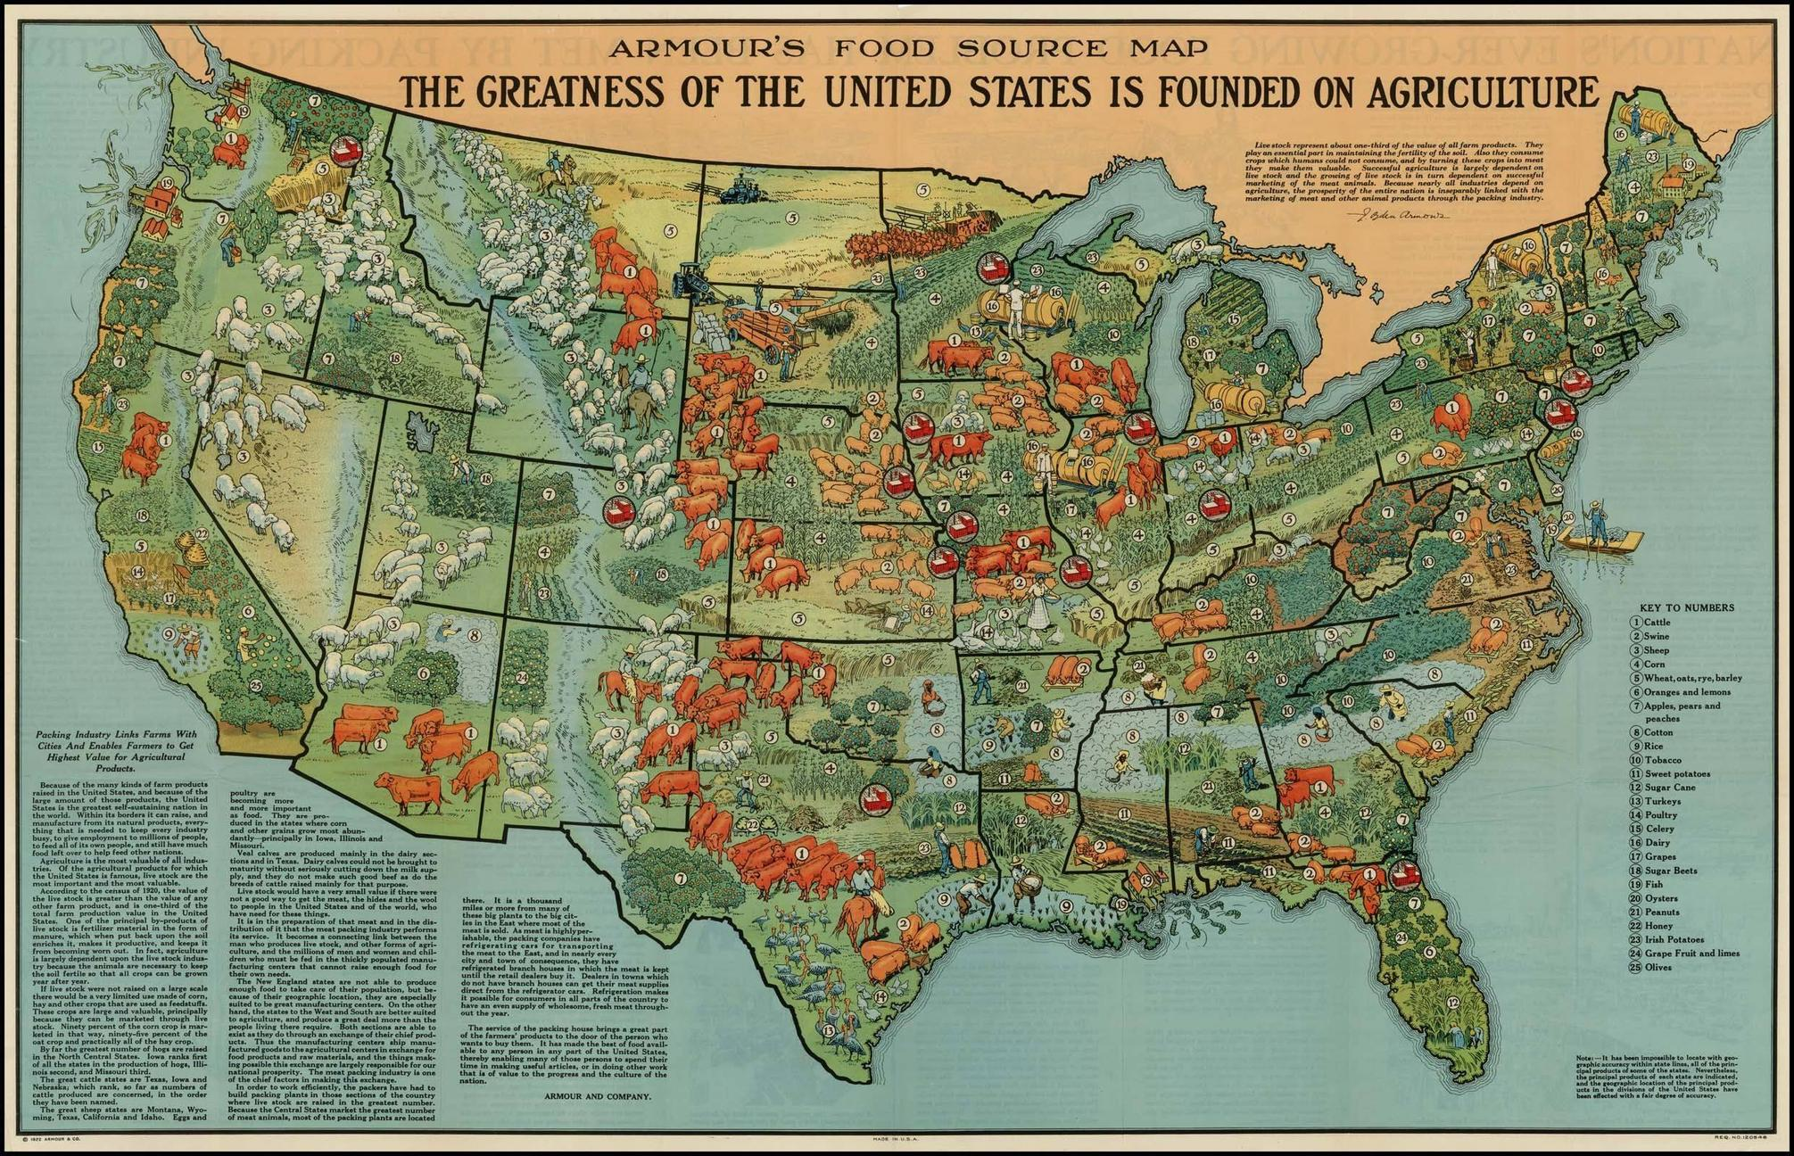
Link Here: https://cdn3.vox-cdn.com/assets/4565227/Old_School_Crops.jpg
Ask, “What states do you notice that have cattle? Are there some areas that seem to grow more?”
Students should label the names of the states they think grow cattle across the United States on their blank U.S. map.
Student Copy Here: https://docs.google.com/presentation/d/1NIrX4mCemGES_qGDTjR6nBVdLU8_b9bnyx9uBXYvTT4/copy
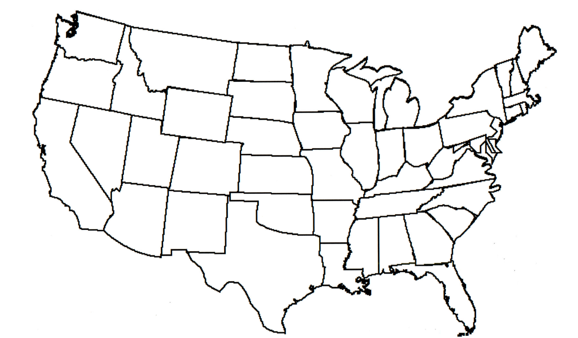

After students have had time to review and label their map. Bring students together. Explain, “Cattle are raised in all 50 U.S. states. However, the vast majority of commercial beef and dairy production is heavily concentrated across the Great Plains, Midwest, and Southern regions due to open pasturelands, access to feed, and climate. North Carolina contributes more than 740,000 head of cattle raised on thousands of primarily small, family‑owned farms across all 100 counties. The beef industry generates hundreds of millions of dollars each year in cash receipts and supports rural communities statewide.”
Interactive Map: https://www.nass.usda.gov/Statistics_by_State/North_Carolina/Publications/County_Estimates/Cattle.pdf
If you would like to incorporate stats and data, here is a great tool National Agriculture Statistics Service https://www.nass.usda.gov/Publications/Highlights/2024/Census22_HL_Cattle%20and%20Cattle%20on%20Feed_final.pdf
Next, provide students with picture cards of different breeds of cattle. Of these common cattle breeds, what parts of the world do they come from? Guide students to notice:
- Pictures of different cattle breeds
Link Here: https://docs.google.com/presentation/d/1NvWPTHBxnfjuXDKGdfogVs6fbaywoAD1/copy
North Carolina Beef Ag Mag: https://www.ncfb.org/wp-content/uploads/2023/02/Beef-AgMag-Final-for-Web.pdf

Guide students to notice:
- “Which states raise the most cattle?”
- “What is the climate, region, and environment like?”
- “What cattle breeds are grown in North Carolina?”

Explain – Main Idea & Details

The teacher will read this short passage aloud to students. You can also share as a PDF for one to one classrooms. Where Cattle Live

Where Cattle Live
The United States is one of the world’s largest beef‑producing countries, with around 94 million cattle raised across the nation. Beef cattle can be found in open pastures and ranches, where farmers and ranchers work daily to care for animals by providing food, water, shelter, and health care. Cattle are raised for more than just food—beef cattle also play an important role in agriculture, culture, and rural communities.
Certain states make up what is often called “cattle country,” with Texas ranking #1 for cattle production, followed by Nebraska, Kansas, Oklahoma, and California. Across the country, farmers raise a variety of cattle breeds, each with unique characteristics, including Angus, Hereford, Simmental, Limousin, Brangus, and Charolais. These breeds come from different parts of the world and are carefully managed to produce healthy animals and high‑quality beef.
Behind every cut of beef is a story of hard work, responsibility, and care—connecting farmers, animals, and consumers from pasture to plate.
Assessment of Understanding
Ask Students:
- “What is the main idea of this page?”
- “What details help explain the main idea?”
Possible main idea sentence: Beef comes from cattle that are carefully raised by farmers and ranchers across the United States.

Elaborate
Students will use the main idea sentence as a paragraph starter to build a main idea paragraph.

Paragraph Starter: Beef comes from cattle that are carefully raised by farmers and ranchers across the United States.

Students will continue by adding information gained from the map search activity. Students will include information such as: the state name, the number of cattle, the type of climate, etc. Provide evidence to write a complete informational text paragraph with at least 4-5 sentences. Students should include the names of the states that were circled on the U.S. map where cattle are raised. Students will be assessed on their knowledge of where cattle are raised and the structure and information included in the paragraph. Assessment Rubric included.

Rubric
Criteria | 2 Points | 1 Point | 0 Points
Topic & Focus | Paragraph clearly explains cattle and where they are raised using the correct topic. | Topic is present but unclear or too general. | The topic is missing or unclear.
Ideas & Content | Includes accurate facts about cattle and locations (U.S. and/or NC). | Some facts included, but information may be incomplete. | Few or no accurate facts included.
Organization | Clear beginning, middle, and ending. | Some organization, but ideas may be out of order. | No clear organization.
Use of Details | Uses specific details (examples, regions, climate, breeds). | Uses general details with little explanation. | Lacks details.
Sentence Structure | Sentences are complete and varied. | Some sentence errors, but meaning is clear. | Many errors make writing hard to understand.
Grammar & Conventions | Correct use of capitalization, punctuation, and spelling. | Some errors, but they do not confuse the meaning. | Frequent errors that make the paragraph confusing.
Learning Outcomes
- I can explain where beef comes from.
- I can use maps, texts, and illustrations to help me understand information.
- I can explain why agriculture is important to communities.

Extension & Evaluate
Activity One
To evaluate student understanding of lesson activity, provide students with Cattle Numbers in North Carolina Worksheet.

Printable Worksheet with Map: https://docs.google.com/presentation/d/1hmpzLgOC26SVbb02jhJa1sCdw_SGkluuu9TryT1iRFs/copy

List the Top Five Beef-Producing Counties in North Carolina
(Write the number of beef cattle in each county.)
Top 5 Beef Counties | # of Beef Cattle per County
1) | 1)
2) | 2)
3) | 3)
4) | 4)
5) | 5)

Students will complete the worksheet based on understanding of North Carolina Beef production. Students may need to research to find accurate data to support this project. Here is a great link: https://www.nass.usda.gov/Statistics_by_State/North_Carolina/Publications/County_Estimates/Beef.pdf

Which region raises the most beef cattle in North Carolina?

Answer Key

Top 5 Beef-Producing Counties in North Carolina (Based on 2024 USDA/NASS beef cow estimates)
Top 5 Beef Counties | # of Beef Cattle
1) Chatham County | ~17,500
2) Randolph County | ~16,000
3) Wilkes County | ~15,500
4) Duplin County | ~12,000
5) Iredell County | ~11,200
[nass.usda.gov] Note: Rankings are based on published county estimates; some counties may have withheld data.

Activity Two
Map Skill
Shade (color in) the top five beef-producing counties on a North Carolina map.
Students will use a digital or print version map to shade in counties from activity one.
Map: https://docs.google.com/presentation/d/1HTkGVCEa0yv6OvGobBULEfz0nzpusUFJo-yOBdjg1FI/copy
Digital or Printable version available: North Carolina Map County Map Printable Version
Students should correctly shade:
- Chatham, Randolph, Wilkes, Duplin, and Iredell

2. Map Skill
Look at a North Carolina land regions map (Mountains, Piedmont, Coastal Plain)

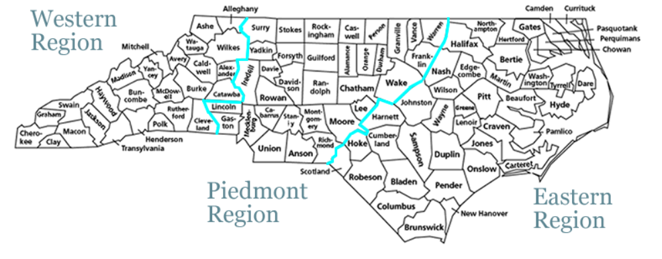
Students should correctly identify regional areas across North Carolina
- Can cattle be grown across the state?
Answer Key: Yes!

3. Region Question
What region has the most cattle producing counties?
Correct Answer: Piedmont Region
Explanation: Most of the top cattle-producing counties (Chatham, Randolph, Iredell, and parts of surrounding counties) are located in the Piedmont region, which has:
- Rolling hills, good pasture land, and strong livestock farming traditions
It is important to remind students some key cattle facts:
- North Carolina has over 350,000 beef cattle statewide, and all 100 counties raise cattle.
Resources

Extension Lesson & Activity
https://agclassroom.org/matrix/lessons/710/

Extension Lesson Plan:
https://www.agintheclassroom.org/media/0yaps2v3/beef-reader-pages-updated-2022.pdf

Websites
https://www.ncbeef.org/
https://www.nass.usda.gov/Statistics_by_State/North_Carolina/Publications/County_Estimates/Beef.pdf

North Carolina County Map and Key
https://web.lib.unc.edu/nc-maps/browse_location.php

