
Ruminants
“What do Cows Eat?”
K-2 Lesson

Lesson Overview
Students explore how ruminant animals, like cattle digest food, recycle materials humans cannot eat, and support environmental conservation. Using informational text and diagrams, students learn about the four-part ruminant stomach, the digestion process, and how cattle convert grasses and by-products into food and useful products for humans.

Background Knowledge
Cows chew food, swallow it, bring it back up as “cud,” and chew it again. Cows are ruminants. That means they have a special stomach with four compartments that help them eat grass and plant parts humans cannot eat. This helps cows get nutrients from grass and plant leftovers. Cows also help the environment by eating food scraps that would otherwise be wasted.

Successful beef production in North Carolina depends heavily on forage management, including the use of fescue, bermudagrass, ryegrass, and clover, along with adaptive grazing strategies that help producers manage seasonal forage shortages and control feed costs.

Producers must also balance nutrition, reproduction, herd health, and genetics through tools such as forage testing, mineral supplementation, defined breeding seasons, and participation in herd improvement programs. Farmers play an important role in growing healthy beef for us to eat.

Along with cattle, other animals such as goats, sheep, buffalo, deer, elk, giraffes, and camels
have a four compartment stomach. These animals are called ruminants. The function of these four compartments allow cattle to physically and chemically digest food that cannot be utilized by humans or animals that only have a simple stomach with one compartment. The ruminant digestive system of cattle actually helps us use feed resources that would otherwise be discarded as waste. These waste products are known as byproducts or incidental products created by the manufacture of something else.

Nearly half of U.S. land is pasture or rangeland that cannot be used for crops directly for human consumption. Ruminant animals make this land productive by turning grasses into food for humans. Cattle also play a vital role as recyclers or upcyclers, consuming food by-products that would otherwise go to landfills. About 85% of the nutrients cattle consume come from sources humans cannot eat, making them models of conservation and efficient resource use.
Understanding what cows eat helps students connect classroom instruction to real‑world agricultural decision‑making, environmental stewardship, and the economic importance of beef cattle production in North Carolina. Here is a great video addition to teach students about ruminants: https://www.youtube.com/watch?v=63Suco814l0

Standards Alignment
Health

K.NPA.2 Understand the importance of consuming a variety of nutrient dense foods and beverages in moderation.
- 1.NPA.2.1 Classify the sources of a variety of foods.
- 2.NPA.1.2 Plan meals that are chosen for energy and health.

Literacy
- RI.K.7 / RI.1.7 / RI.2.7 Use illustrations and details to describe information

Science

K-LS1-1Use observations to describe patterns of what plants and animals (including humans) need to survive.

1-LS1-2 Read texts and use media to determine patterns in behavior of parents and offspring that help offspring survive.

2-LS4-1 Make observations of plants and animals to compare the diversity of life in different habitats.

Learning Objectives
Students will be able to:
- I can tell that cows are special animals called ruminants.
- I can explain that cows chew their food more than once.
- I can help make “cow food” using snacks.

Vocabulary
Beef – meat from cattle
Cattle – cows raised on farms or ranches
Breed – a type of animal with specific traits
Rancher - a person who raises animals
Farmer – a person who raises animals and produces crops for food
Production – how food is grown or raised
Ruminants - an animal that chews food more than once
Ration - A specific "recipe" of food designed to keep an animal healthy.
Commodity - a basic, interchangeable good or raw material used as an input in the production of other goods or services

Materials
- Cattle breed cards
- Projected or printed copies of maps
- Pencils / coloring supplies

Lesson Activities

Engage
How many mammals do you know that can turn grass into milk or meat for human consumption? You probably cannot name anything other than a cow. If you said COW, you are correct.
Show a picture of beef cattle (breed pictures are provided).
The teacher will then ask students:
- “What animal is this?”
- “What do we get from this animal?”

Students should identify cows as providing meat and milk. Some may even identify hamburger, steak, ribs, milk, and more. Say: “We eat food to grow and get nutrients, but have you ever wondered what the cow eats? What makes it grow?” Prompt students with questions again to ensure a collaborative discussion.

Ask:
- “What do cows eat?”
- “Do cows eat grass?”

Show a picture of a cow grazing. The teacher will then explain how cows eat grass. Say: “Cows eat food that people can’t eat, like grass! You and I, we can’t eat grass…but the cow is an amazing animal. It can literally make life sustaining protein and dairy, as well as other products by eating grass!”

Say: “Cows have special tummies. They chew their food, swallow it, and chew it again!”
Have students practice chewing motions (big, silly chews). Cows are ruminant animals.

Show a diagram of a cow. Say: “Let's take a look at the diagram of the cow.” A diagram is a picture that displays parts of an object. The teacher will explain more about a ruminant animal. Say: “A cow has 1 stomach with 4 compartments.” Show students a diagram of the ruminant. Say:”That means they have a specialized stomach that helps them eat grass and plant parts humans cannot eat. Cows chew food, swallow it, bring it back up as “cud,” and chew it again.”

Explore
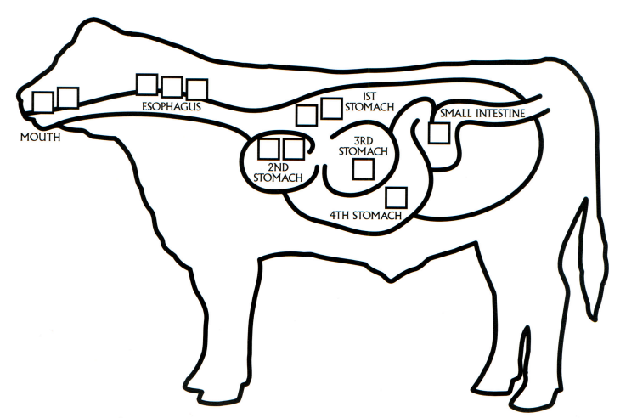
Say: “Let’s try it!” “Okay, we are going to get some grass and with our hands we are going to “chew” the grass. Now imagine you swallow it, place it into a bag. Pass the bag, the next student will mush it up a bit. Then pass the bag back, take the grass out of the bag, “chew” it again (mush it with your hand). Then swallow (put it back in the bag). This is similar to the process a cow goes through when chewing cud.
Chant together: “Chew, swallow, chew again!”

Using a simple diagram:
- Food goes in the mouth
- Goes to stomach
- Comes back up (cud!)
- Gets chewed again

Explain & Elaborate
Raise your hand. Ask: “How many of you would want to eat your food the way a cow does?”
Encourage students to learn more about the amazing ways cows work to get the nutrients they need to provide people (you and I) with quality protein. Say: “When we go to the grocery store or a restaurant to order a steak or a hamburger we want quality beef. To get quality beef, farmers must ensure the cows each have a special diet, cows eat many mixed plant foods.”

Say: Today we are going to act as farmers by creating feed full of nutrients that help their cows grow big and strong. Tell students: “Don’t worry, we are NOT eating grass or other cow food—we are pretending to be the farmers making it!”

Say: “Cattle require specific nutrients for their dietary needs. Just like we should eat the right amount of healthy foods, so should a cow. Cows require the right amount of carbohydrate, protein, lipids, and vitamins/minerals.” “Today, we are going to learn about some of the common feeds used in cattle rations. These are the things cows need to grow big and strong.”
- Carbohydrates - Corn, grasses
- Proteins - Legumes, soybean meal
- Lipids - Cottonseed
- Vitamins/Minerals - Salt

Prior to this lesson activity, please ensure any food allergies for students in the classroom. This is an activity that could be a healthy snack for students (teacher discretion advised).

Say: “Now today, we are not going to make real cow feed, but instead we are going to use items that symbolize the specific things cows eat.” Show students individual items they will be working with today.
- Carbohydrates: popcorn, rice chex
- Protein: peanuts, walnuts, pecans
- Fats: pumpkin seeds
- Vitamins/Minerals: pumpkin seeds

Activity: Trail Mix Station
Provide each student with a small bowl or plastic bag. Students will rotate through each of the 4 stations. At each station students will learn a little about proteins, carbohydrates, fats, and vitamins/minerals. Students will also learn about measurement (these measurements are for visualization only, not actual amounts given to an animal). For younger students, having items pre-measured is a great alternative. Students will add ingredients one at a time.

Station 1: Protein: 1 scoop (.5 cup)
- Peanuts, walnuts, pecans
Protein helps cows grow muscles, repair their bodies, and stay strong. Cows get protein from grasses and legumes, soybean meal, and sometimes supplements in feed. Protein builds muscle and keeps the immune system strong.
Stations 2: Carbohydrates: 3 scoops (.5 cup)
- Popcorn, rice chex
Carbohydrates give cows the energy they need to walk, eat, grow, and stay active. Different things cows eat to get carbohydrates include: grass, hay, corn, and grains. Cows need carbohydrates to move and stay active. It is good for a healthy heartbeat, digestion, and it supports growth.
Station 3: Fats: 4 spoonfuls (tablespoon)
- Pumpkin Seeds
Fats are necessary when cows need extra energy, their bodies use fat. Cows get fats from natural fat in feed, some grains and supplements. Fats are important because they help keep cows warm in cold weather and support healthy body condition.
Station 4: Vitamins/Minerals: 1 spoonful (tablespoon)
- Banana Chips- crushed
Vitamins and minerals are tiny helpers inside the body that keep everything working correctly. Some include: calcium for strong bones, vitamin A for good eyesight, salt and minerals for body balance.
If a simpler option is needed: an alternative to the above items to model a cow’s diet can be substituted with:
  - “Grains” (Cheerios)
  - “Dry plants” (pretzels)
  - “Leftover plants” (raisins)
Evaluate
After, students have had the chance to look at the different foods and do a taste test of the different snacks. Give students a blank coloring sheet of a cow and have students draw how the cow’s stomach looks and how it works.
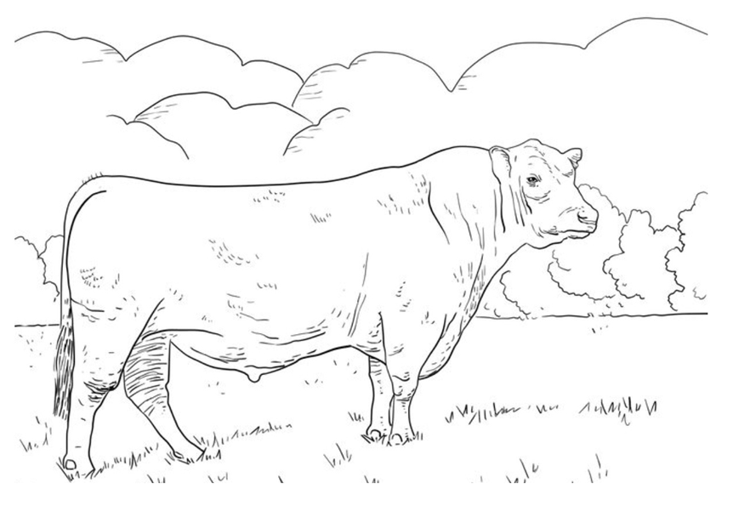

(Optional) If you would like to show students a short video explaining how the ruminant stomach works click here.
- This video explains how cows (ruminants) digest their food using a special four-part stomach. It shows that cows can eat grass and plants that humans cannot digest, and then turn that food into energy and nutrients.
- Video take-aways: Cows have a four-part stomach:
- Rumen – where food is fermented and broken down by bacteria
- Reticulum – helps form “cud” (partially digested food)
- Omasum – absorbs water and nutrients
- Abomasum – the “true stomach” where chemical digestion occurs- just like in a person’s stomach
In a simpler form: First, cows chew their food, swallow it, then bring it back up (chew cud) to break it down more. Then, tiny microorganisms in the rumen help cows digest tough plants like grass. This system allows cattle to turn plants and by-products into energy, helping produce food for people.

Assessment of Understanding

K-2 Open Response Questions
- What kinds of food do cows eat?
- How many stomach parts does a cow have?
- Why do cows chew their food more than once?
- What is one thing cows need to stay healthy?
- Can humans eat grass like cows? Why or why not?

3-5 Open Response Questions
- What happens to food in the rumen?
- Why is chewing cud important for cows?
- What job does the omasum do?
- How do bacteria help cows digest food?
- How do cows help turn plants into food for humans?

Closing

Resources
Extension Lesson Plan:
https://www.agintheclassroom.org/media/0yaps2v3/beef-reader-pages-updated-2022.pdf

AgMag
https://www.ncfb.org/wp-content/uploads/2023/02/Beef-AgMag-Final-for-Web.pdf

Websites
https://www.ncbeef.org/
https://www.beefitswhatsfordinner.com/raising-beef/production-story

