From Pasture to Plate: Learning About the Cattle Life Cycle
K-5 Lesson

Lesson Overview
There are a lot of connections in agriculture; it takes many people and different jobs to provide food for us. The farmer is the beginning of the process and the consumer is at the end. All of the people involved in helping the farmer produce food, process it, transport it and sell it are involved in agriculture. Students will explore where beef comes from, how cattle are raised, and the important role farmers and ranchers play in caring for animals and providing food.

Background Knowledge

The North Carolina beef cattle industry plays a vital role in the state’s agricultural economy and provides an important context for understanding beef production systems used locally and nationally. With more than 700,000 head of cattle raised on thousands of primarily small, family‑owned farms across all 100 counties, beef generates hundreds of millions of dollars each year in cash receipts and supports rural communities statewide.

Successful beef production in North Carolina depends heavily on forage management, including the use of fescue, bermudagrass, ryegrass, and clover, along with adaptive grazing strategies that help producers manage seasonal forage shortages and control feed costs.

Producers must also balance nutrition, reproduction, herd health, and genetics through tools such as forage testing, mineral supplementation, defined breeding seasons, and participation in herd improvement programs. Increasing interest in grass‑fed and direct‑to‑consumer beef, along with strong youth involvement through FFA and 4‑H programs, reflects the industry’s focus on sustainability, animal welfare, workforce development, and future growth.

Understanding these systems helps students connect classroom instruction to real‑world agricultural decision‑making, environmental stewardship, and the economic importance of beef cattle production in North Carolina.
Lesson Takeaways
- Cattle help people in many ways.
- Cattle live on farms and ranches.
- Cattle give us food and other useful products.
- Farmers and ranchers take care of animals and land.

Standards
Reading Informational Text
- RI.K.1 - 2.1 – Ask and answer questions about key details in a text
- RI.K.2 - 2.2 – Identify the main topic and retell key details
- RI.K.3 - 2.3– Describe the connection between two events or ideas
- RI.K.7 - 2.7 – Use illustrations to describe key ideas

Science

1.L.1 – Understand characteristics and behaviors of animals
- 2.L.1 – Understand plant and animal life cycles
- K.E.1 / 1.E.1 / 2.E.1 – Observe how animals interact with the environment
- LS1.B: Growth and Development of Organisms – Adult plants and animals can have young. In many kinds of animals, parents and the offspring themselves engage in behaviors that help the offspring to survive.
- LS1.C: Organization for Matter and Energy Flow in Organisms – Food provides animals with the materials they need for body repair and growth and the energy they need to maintain body warmth and for motion.

Reading Informational Text
- RI.3.2, RI.4.2, RI.5.2 – Determine the main idea of a text; recount the key details and explain how they support the main idea.
- RI.3.7, RI.4.7, RI.5.7 – Use information gained from illustrations (e.g., maps, photographs) and the words in a text to demonstrate understanding of the text (e.g., where, when, why, and how key events occur).
- RI.4.3: Explain events, procedures, ideas, or sequences in a scientific text, including what happened and why, based on specific information in the text.

Science

3.E.2 – Understand the structure and properties of Earth materials
- 3.E.2.1 - Compare Earth’s land features (including natural resources)

3.L.2 – Understand how plants survive
- 3.L.2.1 Explain plant growth based on environmental conditions
- 3.L.2.2 Explain how plants are used for food and fibers

4.L.1 – Understand ecosystems and interactions
- 4.L.1.1 Give examples of how plants and animals interact in ecosystems
- 4.L.1.2 – Explain food chains and energy flow

National Agricultural Literacy Outcomes: Upper Elementary Grades 3–5
Theme 2: Plants and Animals for Food, Fiber, and Energy
Science
- Understand the concept of land stewardship and identify ways farmers care for land, plants, and animals (T2.3-5.e)
- Provide examples of specific ways farmers meet the needs of animals (T2.3-5.d)

Theme 5: Culture, Society, Economy & Geography
Social Studies
- Explain how agricultural events and inventions affect how Americans live today (e.g., Eli Whitney - cotton gin; Cyrus McCormick - reaper; Virtanen - silo; Pasteur - pasteurization; John Deere - moldboard plow) (T5.3-5.c)

Vocabulary
Cow – An adult female cattle that has given birth to at least one calf.
Calf – A young cattle, usually less than one year old.
Bull – An adult male cattle that is not castrated and is used for breeding.
Steer – A male cattle that has been castrated and is raised mainly for beef.
Ranch/Farm – A place where cattle are raised and cared for, including land, buildings, and equipment used for agriculture.
Pasture – An open area of land covered with grass or other plants where cattle graze (eat).
Beef – Meat that comes from cattle and is eaten by people.
Grass – A type of plant that grows in fields and pastures and is the main food source for grazing cattle.
Colostrum - The very first milk from a mother cow, filled with "superpowers" to keep the calf healthy.
Weaning - The process of a calf moving from milk to forage/grain.
Ruminant - An animal with a four-part stomach that can eat grass.
Ration - A specific "recipe" of food designed to keep an animal healthy.

Lesson Activity
Engage
Begin discussion with students by asking: “What do you think of when you think of a cow?” Depending on the age of the student some answers may be milk from a milk cow (dairy) or hamburger from a cow (beef cow). Allow students to list other foods (you can create a quick visual chart of what students say).

Say, “WOW! I am impressed at how much you already know about cows. We can all agree that cattle give us food like cheeseburgers and milk.
- Kindergarten ages should participate in this with a whole group activity, the teacher will lead the students in common thinking about things that come from a cow.
- First-Second Grade ages may be able to create their own anchor charts.
  - Title: “Cattle Help Us! Add pictures/words:
    - Food
    - Clothes
    - Sports
    - Farms

Explore & Explain
Students will understand that beef comes from cattle and is a food people eat. Ask: “Who likes hamburgers?” Explain gently: Beef comes from cattle and beef helps our bodies grow strong. It provides us with important things like protein and iron. Say: “Today, we are going to explore the animal life cycle of cows.
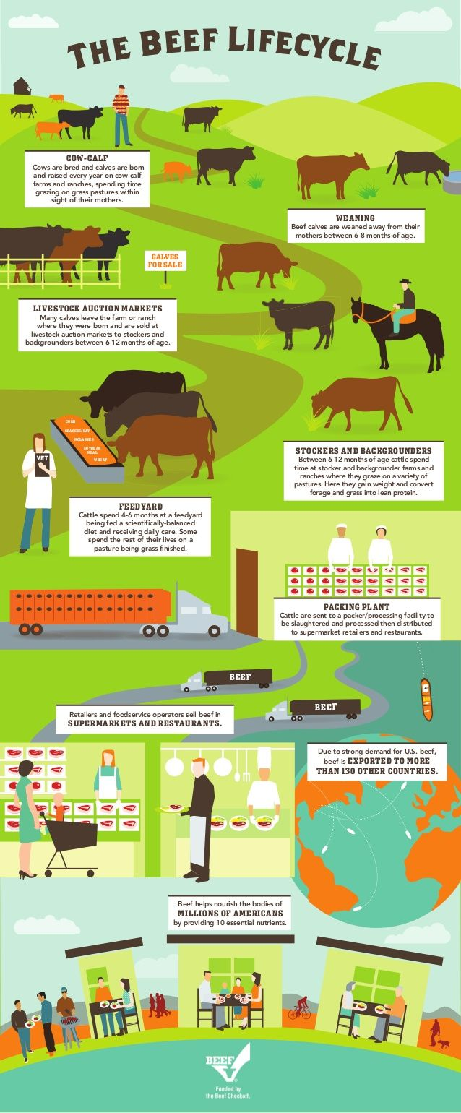
Show students a simple flowchart
Cow → Farm → Store → Plate

I. The Cow-Calf Stage (Birth)
- Concept: Life begins on the ranch. Calves rely on colostrum (first milk full of antibodies) to survive.

II. Weaning (6–8 Months)
- Concept: Just like humans grow up and go to school, calves must learn to be independent.

III. Auctions (6–12 Months)
- Concept: Farmers buy and sell cattle based on their needs. This is the "business" side of ranching.

IV. Stockers & Backgrounders (6–12 Months)
- Concept: Cattle spend this time eating forages (grass/hay) to grow bone and muscle.

V. The Feedyard (4–6 Months)
- Concept: Cattle eat rations—scientifically balanced meals.
- Scaffold: A ration is a balanced plate of food, just like your dinner!

VI. The Packing Plant
- Concept: The animal is humanely harvested and turned into food.
- Activity: Show a "Wholesale Cuts" diagram (Chuck, Rib, Loin, Round). Explain how one animal provides many different types of meals.

VII. Supermarkets & Restaurants
- Concept: The "Cold Chain." Beef must stay refrigerated from the plant to the store to stay safe and fresh.

VIII. The Table
- Concept: Beef is a nutrient-dense protein that ends up in our plates as a delicious meal.

The teacher will give a clear explanation of each stage as the beef life cycle progresses. It is important to explain gently with younger children and explain that animals were put on the planet to provide nourishment for humans. Animals, like cows, are raised for a greater purpose and that purpose is to feed people.

Lesson Activity: The Beef Life Cycle Puzzle
Materials
- Puzzle: https://docs.google.com/document/d/1h4D5SPpA85CR6DbQpKvtNm8cRqsqeiF0VI1dM-XJjeU/copy
Print for individual student use or as a group. Prior to lesson activity cut out the puzzle pieces for easy access.
Students will put together the puzzle pieces to understand the stages of the beef life cycle.
- Ask: “What jobs or careers do you notice when looking at the beef life cycle?” Allow students time to brainstorm and answer. Guide students in understanding if they have questions about specific jobs.
- Say: “We have learned a lot about the cattle life cycle, but now we are going to look at the people who help raise these animals to provide us with a healthy food source.” Show pictures of careers: farmer/rancher, veterinarian (large animal), and more.
- Students will identify a farmer or rancher as someone who helps care for cattle.

Teaching Steps
- Read short excerpts about farmers/ranchers.
A farmer or rancher is the cow-calf producer. They take care of mother cows and their calves. They make sure the animals have food, water, and shelter. Farmers and ranchers help calves grow strong and healthy before they are sold to other farms.
- Discuss:
  - What do they do?
  - Why is their job important?

Lesson Activity: Career Connections
Create a food web to show how many career connections can be made to all the things that take place to get from the farmer to the consumer. Ask students: “How many people does it take to get the cow from pasture to plate? Most student responses will be the farmer, veterinarian, maybe even a chef/cook. Extend students thinking to include the truck driver, butcher, cashier, meat inspector, and so much more.
- Provide students with picture cards to connect together to create the food web. Leave a few blank for other student ideas.

Here is a breakdown of possible ideas/connections within the web:
- Farmer → seed salesman, veterinarian, feed salesman, animal health products salesman, animal nutritionist, extension agent, and more.
- Farmer → buyers, truck driver, auctioneer, cattle sellers, processors, butcher, food wholesalers, buyers for food chains (think Hardee’s, McDonald’s, Texas Roadhouse, and more), grocery stores, cashier, shelve stockers, chef, parents cooking, and more.
- All these and more come together so I can eat delicious food like cheeseburgers, steaks, and other beef projects.

Career Experts (a few examples):
Feedlot Manager
A feedlot manager takes care of cattle as they grow bigger and get ready for market. They make sure the animals get the right food to grow and stay healthy.

Animal Nutritionist
An animal nutritionist studies what cattle eat. They create balanced diets using grains and by-products to help cattle grow and stay healthy.

Veterinarian
A veterinarian is a doctor for animals. They check cattle for sickness, give vaccines, and make sure animals stay healthy throughout their lives.

Farmer (Feed Producer)
Farmers grow crops like corn and hay that cattle eat. They help provide food for the animals and may also grow crops that produce by-products used in cattle feed.

Meat Processor
A meat processor works in facilities where cattle are processed into beef products. They help prepare meat safely so it can be sent to stores and restaurants.

Truck Driver (Livestock Transporter)
Truck drivers transport cattle or beef products between farms, feedlots, and stores. They make sure animals and food arrive safely and on time.

Grocer or Butcher
Grocers and butchers prepare and sell beef to customers. They make sure the meat is fresh and ready to cook.

Food Safety Inspector
Food safety inspectors check meat to make sure it is safe to eat. They follow strict rules to protect people’s health.

Marketing Specialist
A marketing specialist helps promote beef products. They create ads and teach people about the benefits of beef and where their food comes from.

After going through the career connections, allow students to role play. Choose a career they would like to do in the cattle life cycle. Students can dress up, create props, and reenact what they think the relationships and connections these careers have with each other.

Evaluate
K-1 Beef Cattle Memory Game
https://docs.google.com/document/d/10qe6KVeeH4lwKiYUaxxPGs-d0pvT8vPd/copy

2-5 - Create a Cattle Life Cycle Poster or Career Poster
- Review slideshow explaining the stages of the lifecycle of cattle. After the presentation students will complete a life cycle poster of a cow - from pasture to plate.

Closing
Our Class Farm Web
In closing, create a class story web from pasture to plate. Allow students to use their posters to group together. Then using a ball of string or twine to create a web between how all of the jobs, careers, and animal life cycle all connect together and work to bring food to the table.

Farm Web Graphics that will help guide student’s thinking about agriculture commodities: https://cdn.agclassroom.org/media/uploads/lp8/My_Farm_Web_2022.pdf

Here is an additional lesson to show how it may look and work: https://agclassroom.org/matrix/lessons/298/

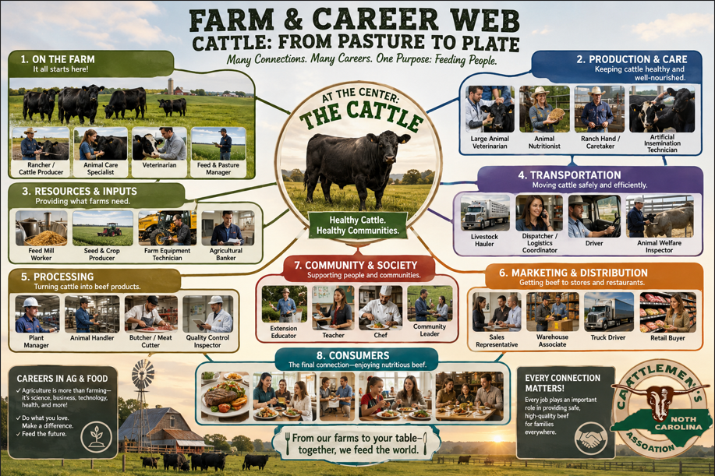
Extension Activities
Interactive Web Based Games
https://www.myamericanfarm.org/games/the-steaks-are-high

Beef Cattle Breed Chart
https://cattle.ca/wp-content/uploads/2022/03/Breeds-of-Beef-Cattle.pdf

Websites
https://www.ncbeef.org/
https://www.beefitswhatsfordinner.com/raising-beef/production-story

AgMag & Supplemental Activity

https://www.agintheclassroom.org/media/k1vp2cqr/beef-ag-mag.pdf
https://www.agintheclassroom.org/media/ekih3dou/agventure-with-beef.pdf

