Cattle Handling & Care
Grades 9-12

Lesson Overview
Students will explore cattle handling, care, and ear tagging as it is used to ensure good cattle health. Students will analyze text, charts, graphs, and images as they interact in a hands-on experience of ear-tagging.

Background
Working with cattle requires an understanding of animal behavior, safety, and proper handling techniques. According to NC State University and NC Cooperative Extension, cattle are prey animals that react to movement, noise, and body position, so calm behavior, proper positioning, and the use of safe handling equipment are essential. These principles are especially important during procedures such as ear tagging, which is used to identify cattle for health records, breeding, and management. Beef Quality Assurance, or BQA standards emphasize that cattle should be properly restrained during tagging to protect both the handler and the animal, and that clean equipment and correct tag placement help prevent injury and infection. By learning research‑based handling and ear‑tagging practices, students can build responsible stockmanship skills that support animal welfare, farm safety, and successful cattle operations.
- Video https://www.youtube.com/watch?v=RRJ1IsPfaVQ
- Youth Quality Care Assurance https://yqcaprogram.org/
- Beef Quality Assurance certification https://www.bqa.org/beef-quality-assurance-certification/online-certifications

Standards
Reading
- CCSS.ELA-LITERACY.CCRA.R.1: Read closely to determine what the text says explicitly and to make logical inferences from it; cite specific textual evidence when writing or speaking to support conclusions drawn from the text.

Speaking and Listening
- CCSS.ELA-LITERACY.CCRA.SL.2: Integrate and evaluate information presented in diverse media and formats, including visually, quantitatively, and orally.
Writing
- CCSS.ELA-LITERACY.CCRA.W.1: Write arguments to support claims in an analysis of substantive topics or texts using valid reasoning and relevant and sufficient evidence.
Consequences of Agricultural Practices
- IMP-5.A.1: Environmental effects of agricultural land use include pollution, land cover change, desertification, soil salinization, and conservation efforts.
Science
Ecosystems: Interactions, Energy, and Dynamics
- HS-LS2-5: Develop a model to illustrate the role of photosynthesis and cellular respiration in the cycling of carbon among the biosphere, atmosphere, hydrosphere, and geosphere.
- HS-LS2-7: Design, evaluate, and refine a solution for reducing the impacts of human activities on the environment and biodiversity.

Lesson Takeaways
- Producer responsibility and cattle welfare
- Proper use of handling aids (flags, paddles—not striking devices)
- Facility inspection and personal safety protocols
- Ear tagging, DNA sampling, PI testing
- Accurate labeling and documentation
Learning Objectives
- Explain humane cattle-handling principles and why stress reduction matters.
- Identify safe facilities and chute practices.
- Demonstrate correct use of handling aids.
Vocabulary
Ear Tag - A numbered identification tag placed in a cow’s ear to track health, ownership, and production records.
Animal ID - A system used to identify individual animals for recordkeeping, traceability, and management decisions.
Breed - A group of cattle with shared physical traits and genetic characteristics, such as Angus, Hereford, or Charolais.
Traceability - The ability to track an animal from birth to processing using identification and records.
Animal Welfare - The humane treatment of animals, including proper care, handling, and minimizing stress.
Cow-Calf Operation - A type of cattle farm or ranch where adult cows are bred and raise calves until they are weaned. Calves nurse from their mothers and graze on pasture before being sold or moved to the next production stage.
Calf - A young bovine, usually less than one year old, that is born on a cow-calf operation.
Weaning - The process of transitioning a calf from drinking its mother’s milk to eating solid feed such as grass and hay.
Cattle Care - Beef producers work to ensure their and the animals’ well being. This includes proper handling techniques, low-stress environments, and providing appropriate facilities so cattle are comfortable and healthy.
Bovine - Animals of the cattle group- cows, oxen, bison, and buffalo

Materials
Informational Passage KBN Cattle Handling Guide
Ear Tag Image Guide
Ear Tag
Stappler/Staples
Herd Data Sheet https://docs.google.com/document/d/1U5Bczl_J37_kvQc5ZZkKY6PfIq7acDKa3lm6bsLf1Pg/copy

Additional Resource/Materials https://docs.google.com/document/d/18jXBFuCKuKRLx9xbmSsYC9KdJq76WoBo7IDLYOZodCM/copy

Lesson Activities
Engage
To begin the lesson, show a short cattle-handling clip or analyze a photo of a cattle chute. In this video clip, you will notice ear tagging practices.
Ask students:
- “Why do you think farmers use this practice?”
- “What steps do you notice the farmer taking?”

Explore
Explain to students this video is a great visual to show the practices in place to ensure cattle health and wellness. Share with students some background information about cattle handling and ear tagging. Then share this informational text article from Kentucky Beef Network.
Students will review handling aids and ear tagging in KBN Cattle Handling Guide
Hands-On/Simulation of Ear Tagging:
- Students walk through a mock chute layout (taped on floor)
- Practice “calm movement” techniques using role-play.
- Group students in partners (2 students per group) and provide each group with needed supplies. Each group will get an ear tagging diagram and an ear tag. One partner will hold the tagging guide, while the other student practices ear tagging. Students will then switch places and reenact the same simulation. Each student should have a turn holding the guide and tagging.
  - A stapler or tape will attach the tag to the ear model. The stapler is a great substitution for the ear tagging tool. Students will use the tool to appropriately tag the ear.
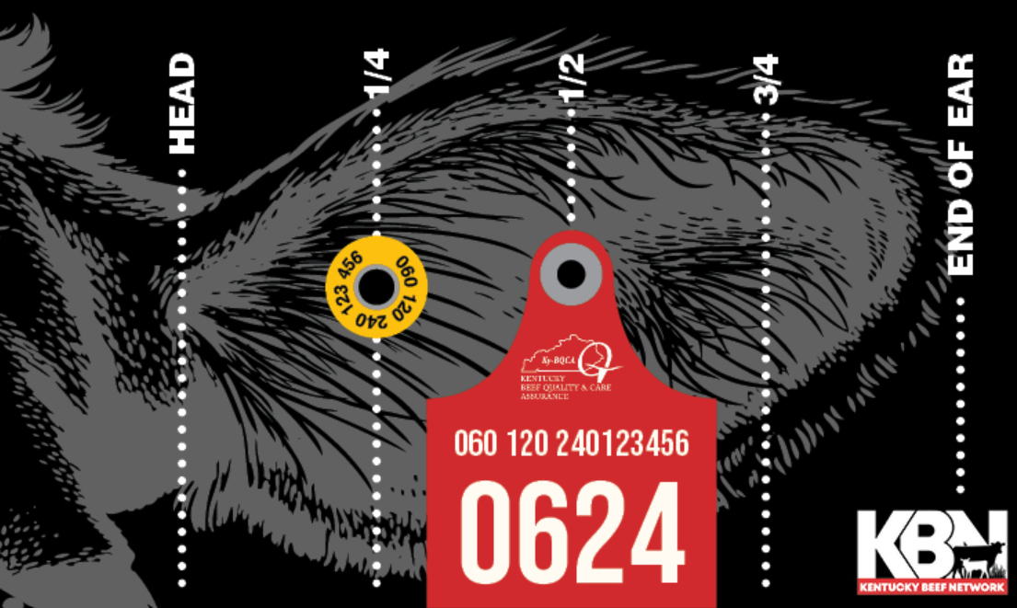
  - Prior to the lesson create cardboard ear tags or print these on cardstock. If supplies allow, create one for each student.
Cardboard Ear Tagging: take a few pieces of scrap card board cut into 2X3 pieces and glue the ear tag guide onto it. Have students practice (if you do not have the appropriate tools, simulate this activity using a paper tag and stapler or glue).

Explain
The teacher will create an opportunity for connection and understanding by referencing the KBN Cattle Handling Guide. Read the following sections about facility inspections and ear tagging. You can also share as a PDF for one to one classrooms.

Read these short sections aloud to students.

- Corral/Working Pens – inspect for loose or broken boards
and wire, broken hinges and latches, and protruding nails
or other hazards. Repair any low areas that are holding
water.

- Squeeze Chute/Head Catch – should be in good working
order and well lubricated. Check for any sharp objects or
broken flooring that needs to be repaired. Check for wasp
and yellow jacket nests in warm weather and exterminate
if found. Take special precautions when cattle are in the
chute to avoid choking.

- Placement of Tag - Place the tag in the middle third of the ear between the rises in auricular cartilage. Get it in the center of the ear not too close to the tip of
the ear or the head. Avoid any major blood vessels.

Explain
Connection and Understanding. Students will recount the important steps in ear tagging.
Ask Students:
- “What is the main purpose of the practices?”
- “What details help explain why these steps are important?”
Extension: Text Annotation & Safety Brief Chart
- Students read excerpts from the cattle care guide and highlight safety rules and rationale.
- Write a one-page safety brief explaining why humane handling reduces risk and improves productivity.
Tomorrow we will take a closer look at how farmers and ranchers document and keep track of cattle in their operation.

Tagging & Identification Skills
Students can:
- Match ear tag numbers to animal records
- Practice proper tag placement using diagrams
- Discuss why identification is critical for health, breeding, and traceability
Day 2
Engage
Bring out ear tagging activity from yesterday. Allow students to share their initial tagging practice, then have them compare to the tagging guide.

Ask students:
- “How did you do?”
- “Were you close to an accurate location?”
- “Do you think you could do this without support or the need of a cattle chute?”
These are questions farmers ask themselves as they go into caring and handling an animal. Say: “Today we are going to explore why farmers use ear tags and the importance they serve.”
Explore
Materials:
Herd Data Sheet https://docs.google.com/document/d/1U5Bczl_J37_kvQc5ZZkKY6PfIq7acDKa3lm6bsLf1Pg/copy
Cattle Breed Profiles: https://docs.google.com/presentation/u/1/d/1q2ljTA0cmU1FyF7CxesJE3_SKDOwXUT9/copy
Explore the herd overview. This is a generated set of information to mimic actual farm data.
Provide students with background farm info:
- Farm Name: Green Farm
- Herd Type: Beef Cow–Calf Operation
- Total Head: 12
- Primary Breeds: Angus, Hereford, Charolais
- ID System Used: Visual Ear Tag + Backup Tattoo (simulated)
This activity can be done independently or in a small group (teacher discretion). Provide students with a copy of the Herd Data Sheet and breed profile cards. Students will read breed profiles (Angus, Hereford, Charolais) and data sheets. Identify key take aways. Then students will match physical traits in the data sheet to breed descriptions.

Cattle Breed Identification Activity
Success Criteria/Objective:
You will analyze herd data and cattle breed information to identify breeds based on physical traits and characteristics.

Materials
- Herd Data Sheet
- Cattle Breed Profiles (Angus, Hereford, Charolais)
- Student Response Worksheet Cattle Breed Identification Activity Sheet.pdf

Before you begin the activity, get to know a little background of the farm:
  - Farm Name: Green Farm
  - Type: Beef Cow–Calf Operation
  - Total Animals: 12
  - Breeds: Angus, Hereford, Charolais

Open the Cattle Breed Profiles. Carefully read about each breed. As you read, write down or highlight: Tip: Focus on what makes each breed easy to recognize.
  - Coat color
  - Body size and shape
  - Distinctive markings
  - Any special traits

Examine the Herd Data Sheet
Look at each animal record, including:
  - Animal ID (ear tag)
  - Physical description
  - Any notes about appearance

Match Traits to Breeds
For each animal: Compare its physical traits to the breed profiles.
- Decide which breed it is most likely to be:
  - Angus
  - Hereford
  - Charolais
- Write your answer next to each animal.
Example: “This animal is Hereford because it has a red body with a white face.”
Record at least one trait that helped you decide.
Explain
Close out lesson activity by asking students probing questions.
Ask:
- “Which breed was easiest to identify?”
- “What was the most difficult?”
- “What is a quality trait you think farmers are looking for?”
- “Do you think ear tagging holds an important role in tracking herd data?”

The teacher will explain the very important process of ear tagging. Say: “Farmers use ear tags primarily for individual identification, to track health records, breeding history, and milk production in herds of hundreds or thousands of animals. These tags enable easy, cost-effective, visual tracking of animal performance, lineage, and age from a distance, with many required by law for disease traceability and movement. Tags are typically applied to the ear shortly after birth, functioning similarly to a human ear piercing. Two tags are often used to ensure at least one remains, even if one is lost. Tags are placed in the center of the ear, avoiding the major ribs of the ear (veins).” Ear tagging is an important job of the farmer and others caring for cattle.

Closing: 3-2-1 protocol activity.
After completing this multi-day lesson, students share their experiences using a 3-2-1 protocol.
How it Works: Instruct students to write 3 things they learned, 2 big ah-ha’s or things they found interesting, and 1 question they have relating to the topic. Here is a quick reference for guiding questions that can be used for a 3-2-1 protocol.

3 Things You Learned (Content Knowledge)
- What are three essential principles of low-stress cattle handling, and why do they reduce risk for both the handler and the animal?
- List three specific reasons why accurate identification and record-keeping (such as ear tagging) are critical for cattle management and traceability.
- Identify three safety hazards that must be addressed during a facility or chute inspection before working with cattle.

2 "Ah-ha" Moments or Interesting Connections (Critical Analysis)
- What was a surprising connection you discovered between the physical behavior of cattle (prey instinct) and the specific handling aids (flags/paddles) used?
- How did the hands-on ear-tagging simulation change your perspective on the level of precision and "stockmanship" required in modern beef production?

1 Remaining Question (Extension/Inquiry)
- Based on what we have discussed about traceability and health records, what is one question you still have about how these practices impact the larger beef supply chain or human food safety?

Extension Activities

Reading Project: Argumentative Writing
- Prompt: Should cattle producers be required to maintain detailed health and ID records?
- Students support arguments using technical evidence and experiences from the lesson.

Math Connection Calculate & Solve
- Average weight by breed
- Percentage of herd by breed
- Weight difference between steers and heifers
- Create a bar graph or spreadsheet summary

Breed Identification
Students can:
- Compare coat color, markings, and frame size
- Identify likely breed traits (growth, temperament)
- Analyze purebred vs. crossbred cattle
- https://www.farmcreditofvirginias.com/sites/default/files/Purebred%20vs.%20Commercial%20cattle.pdf

Resources

Websites

https://www.ncbeef.org/
https://www.beefitswhatsfordinner.com/raising-beef/production-story

