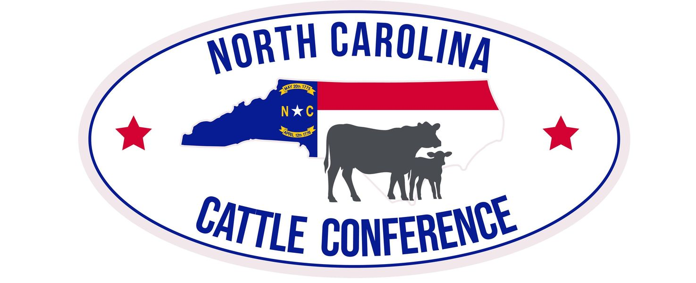
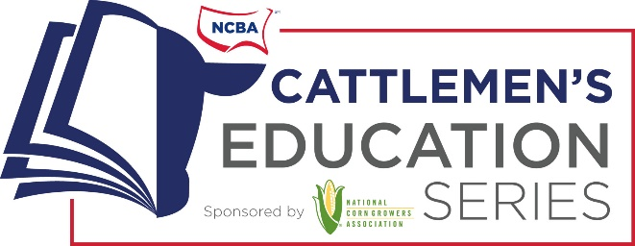
Tentative Schedule of Events
Title: Taking Beef Quality Assurance Full Circle: Building Quality from Pasture to Plate
Theme: The Right Way Is The Only Way
Friday, February 23, 2024
7:30 a.m. Board of Directors Breakfast
8:00 a.m. Registration
8:45 a.m. Welcome, Dr. Todd See
9:00-10:15 a.m. Opening Session: Lisa Pederson (North Dakota State University)
10:15-10:30 a.m. Herd Health: Emerging Issues in Animal Health- Dr. Catherine Harris, Dr. Kevin Lahmers (Associate Director of Lab Services at Virginia Tech)
10:45-11:45 a.m. Breakout Sessions
- Heifer Development-Dr. Troy Rowan (Beef Specialist at Tennessee) Conover __

- Low Stress Livestock Handling-Kevin Thompson (Middle Tennessee Research Station) Conover __

- Regenerative Grazing- Dr. Allen Williams (Soil Academy) Conover ___

12:00 p.m. Luncheon
Speaker: Colin Woodall, NCBA
Mile of Fence Presentation
1:30 p.m. Trade Show Continues

2:00 p.m. Committee Meetings- Everyone welcome
Forage & Grasslands Committee
Stocker & Cattle Feeder Committee
Cattlewomen (NC Agromedicine Institute- Farm/Life Balance, Fact or Fiction?)
3:00 p.m. Afternoon Break
3:00 p.m. Committee Meetings Continue
Purebred Breeders Council
NC BCIP- Troy Rowan and Kevin Thompson
Joint Legislative/Membership (Kent Bacus, NCBA, Colin Woodall, NCBA and Angie Maier, NCCA Contract Lobbyist)
5:00 p.m. NCCA Joint Board of Directors & Annual Business Meeting Catawba 2
6:00 p.m. Brisket Bites, NCBA PAC & NCCA Support Auction, Past President’s Reception, Young Producers, and Collegiate Cattlemen in Trade Show

Continued below

Saturday, February 24, 2024

7:00 a.m. Registration
7:30 a.m. Youth Recognition Breakfast
9:00 a.m. Trade Show Opens
9:15 a.m. Morning Sessions- ______________
Reproduction and Herd Health (Drs. Felipe Silva and Tom Van Dyke) Conover 2
(Note: Add Consultants and Genetic Companies)
10:30 am
How to Work Cattle Together and Remain Friends (NC Agromedicine Institute) Conover 2
Add-Ons
9:30-10:00 a.m. - BQA Transportation and Trailer Safety (NCDA Station Staff)
10:00-10:30 a.m. –Meats (Currey Nobles)
10:30 NC Agromedicine (working cattle as a family)
10:30-11:00 a.m. - Emergency Action Plans and Weathering the Storm (Dr. Deidre Tigue /Ethan Henderson/Buron Lanier)
Skillathon Contest- Brent Jennings (Trade Show)
BQA Certification- NCSU Extension Booth
12:00 p.m. Adjourn

